Database Schema: University Course Management
Table 1: Student
CREATE TABLE Student (
student_id INT PRIMARY KEY,
name VARCHAR(50),
department VARCHAR(30),
year INT
);
Table 2: Course
CREATE TABLE Course (
course_id INT PRIMARY KEY,
course_name VARCHAR(50),
credits INT,
instructor VARCHAR(50)
);
Table 3: Enrollment
CREATE TABLE Enrollment (
enroll_id INT PRIMARY KEY,
student_id INT,
course_id INT,
marks INT,
semester VARCHAR(10)
);

Sample Data:
Student
INSERT INTO Student VALUES
(1,'Amit','CSE',3),
(2,'Neha','CSE',2),
(3,'Ravi','ECE',3),
(4,'Suman','ECE',4),
(5,'Karan','ME',2),
(6,'Pooja','CSE',4),
(7,'Ankit','ME',3),
(8,'Meena','CSE',1);
Course
INSERT INTO Course VALUES
(101,'DBMS',4,'Dr. Rao'),
(102,'OS',4,'Dr. Mehta'),
(103,'CN',3,'Dr. Rao'),
(104,'AI',4,'Dr. Sharma'),
(105,'ML',3,'Dr. Sharma');
Enrollment
INSERT INTO Enrollment VALUES
(1,1,101,78,'2024S'),
(2,1,102,82,'2024S'),
(3,2,101,65,'2024S'),
(4,2,103,70,'2024S'),
(5,3,101,60,'2024S'),
(6,3,104,88,'2024S'),
(7,4,102,75,'2024S'),
(8,4,104,90,'2024S'),
(9,5,101,55,'2024S'),
(10,5,103,58,'2024S'),
(11,6,104,92,'2024S'),
(12,6,105,85,'2024S'),
(13,7,102,68,'2024S'),
(14,7,105,72,'2024S'),
(15,8,101,80,'2024S');

Questions:
- Find the average marks of each course but show only courses whose average is ≥ 75.
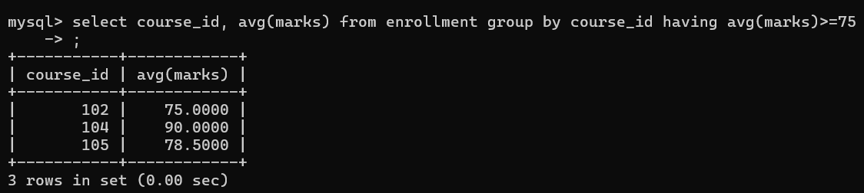
- Count how many students enrolled in each instructor’s courses.
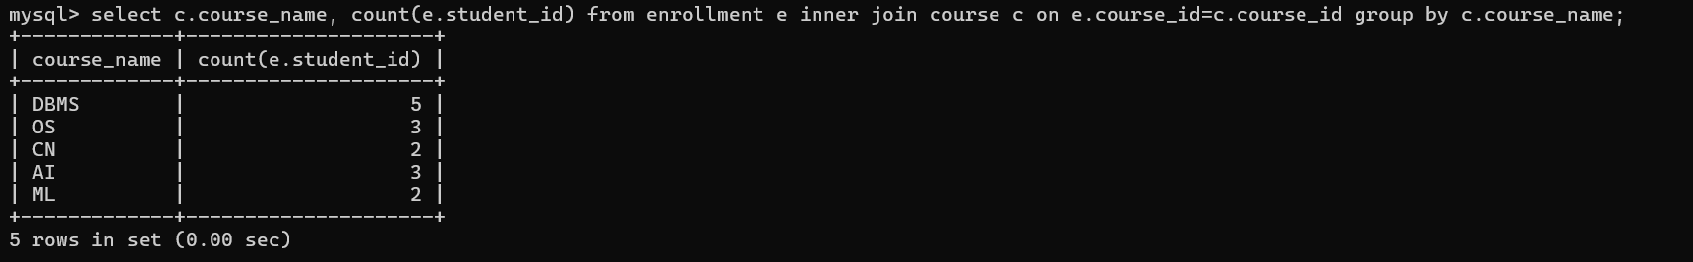
- Display department-wise maximum marks obtained by any student.
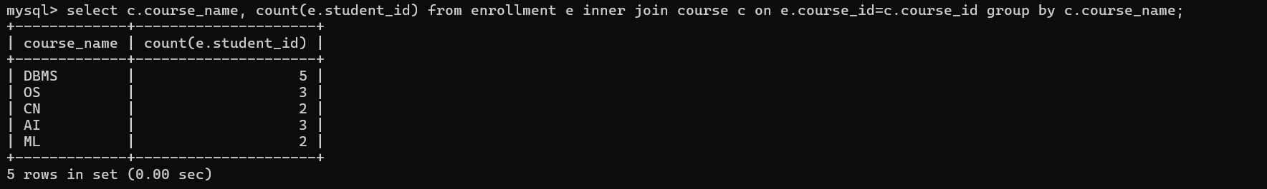
- Find the course with the highest average marks.
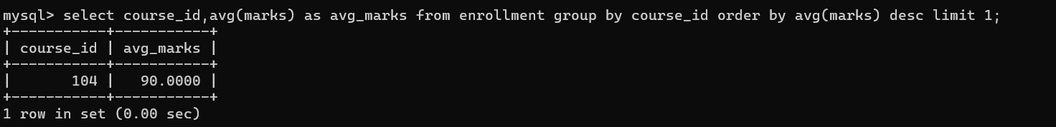
- List departments where more than 2 students have appeared in DBMS.
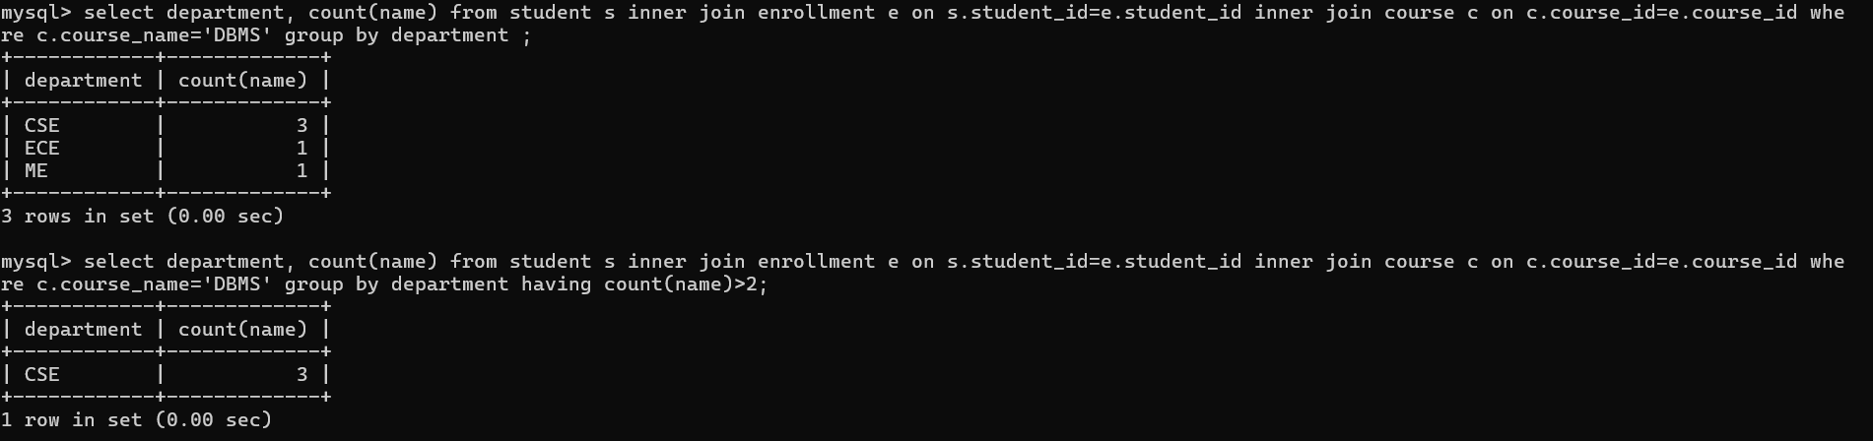
- Find instructors whose average student marks exceed the overall average marks of all students.
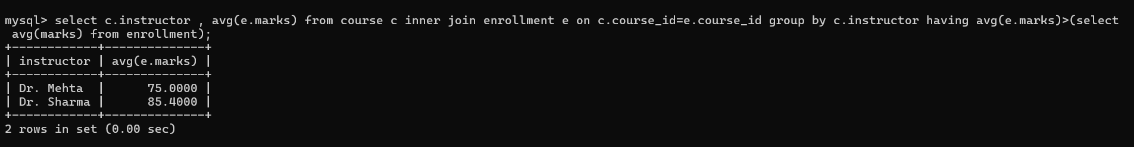
- Show courses where minimum marks ≥ 60.
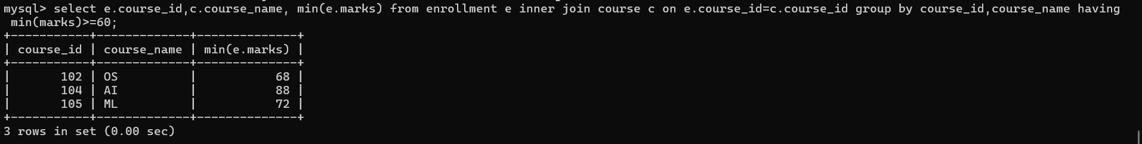
- Find students who scored more than the average marks of their respective course.
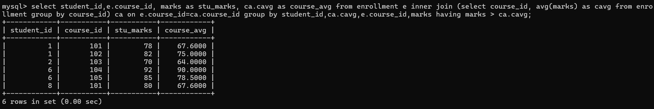
- List students who scored less than the average marks of DBMS.
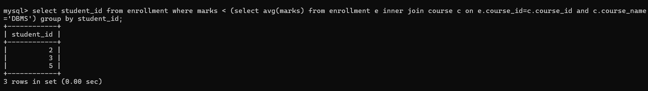
- Find courses whose average marks are higher than AI’s average marks.
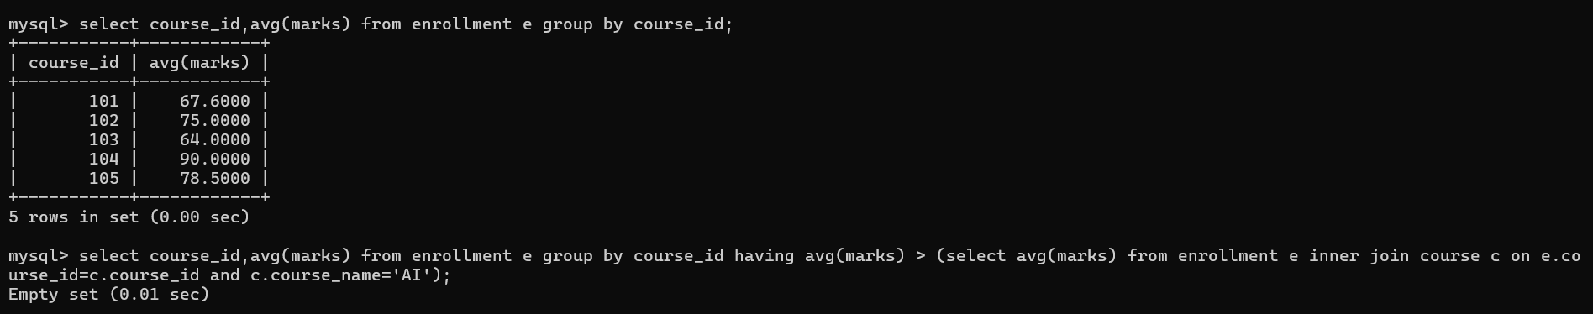

- Display students who are enrolled in more courses than the average enrollment per student.
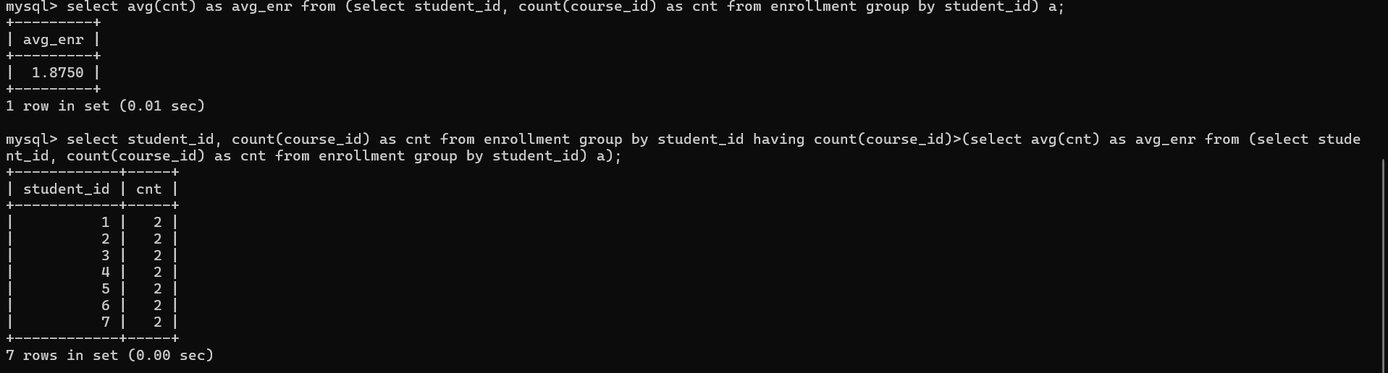
- Find names of students who have never scored below 70 in any course.
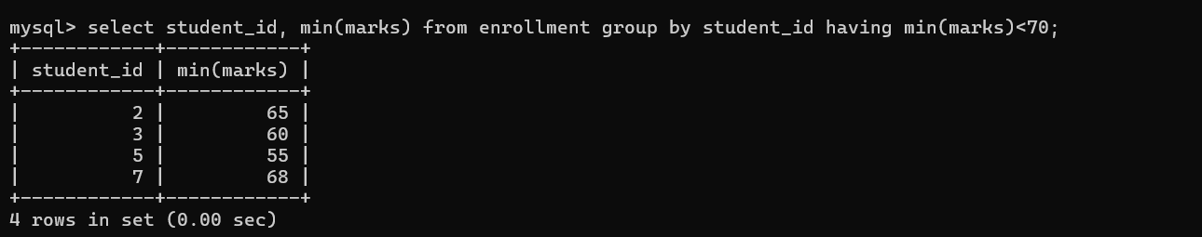
- List students who are enrolled in all courses taught by Dr. Sharma.
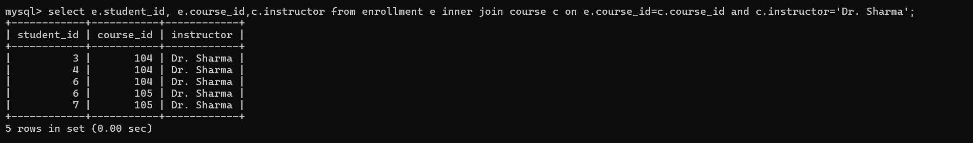
- Find instructors who teach more than one course.
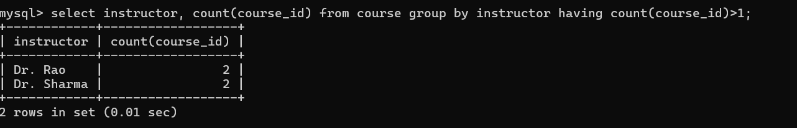
- Display top 3 students based on average marks.
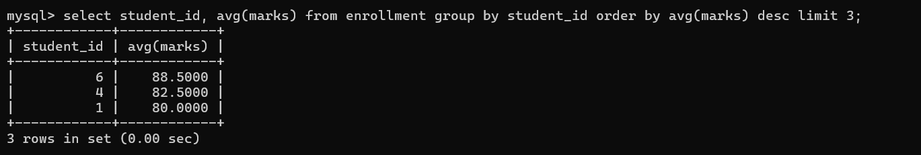
- Find the second highest mark obtained in DBMS.
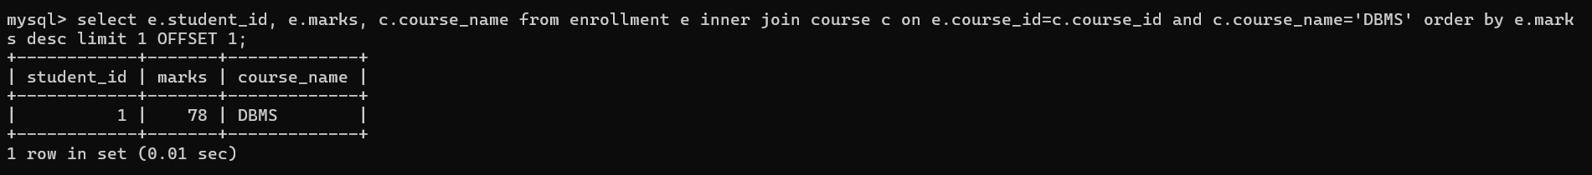
- Show top 2 courses with the highest number of enrollments.
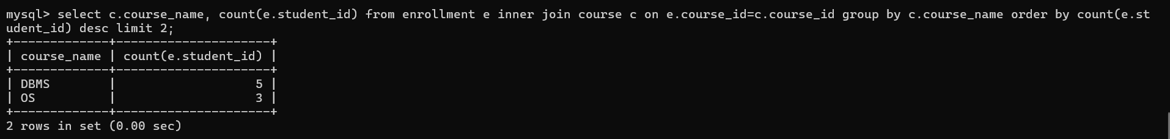
- Display output as
Student: Amit (CSE) - Avg Marks: 80.00
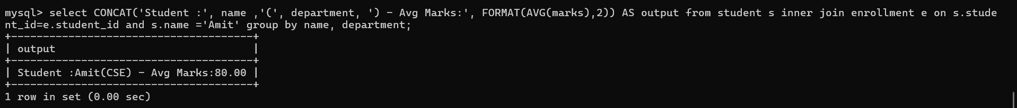

- Show
Course: DBMS | Instructor: Dr. Rao | Avg Marks: XX
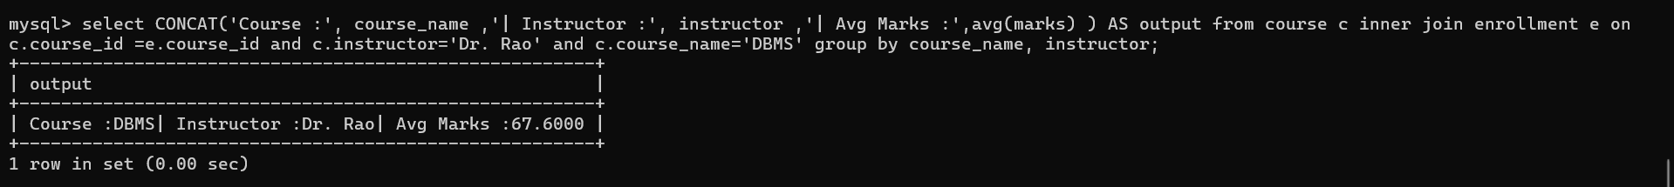
- Find students who scored above department average but below overall university average.
